Practical No. 6

**Shape data**

To shape data in Power Query Editor, you provide step-by-step instructions for Power Query Editor to adjust the data as it loads and presents the data. The original data source isn't affected; only this particular view of the data is adjusted, or *shaped*.

The steps you specify (such as rename a table, transform a data type, or delete a column) are recorded by Power Query Editor. Each time this query connects to the data source, Power Query Editor carries out those steps so that the data is always shaped the way you specify. This process occurs whenever you use Power Query Editor, or for anyone who uses your shared query, such as on the Power BI service. Those steps are captured, sequentially, in the **Query Settings** pane, under **APPLIED STEPS**. We’ll go through each of those steps in this article.

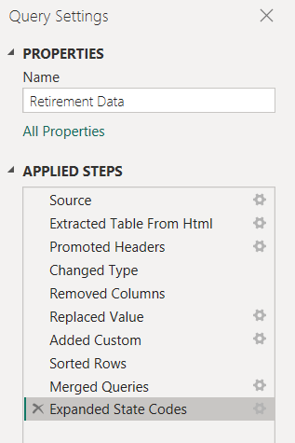

1. Import the data from a web source. Select the **Get data** dropdown, then choose **Web**.

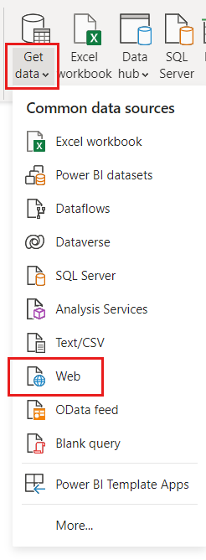

1. Paste this URL into the **From Web** dialog and select **OK**.

Copy

https://www.fool.com/research/best-states-to-retire

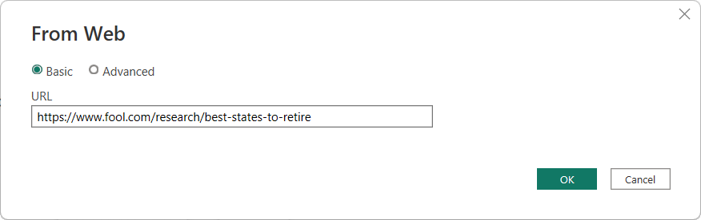

1. In the **Navigator** dialog, select Table 1, then choose **Transform Data**.

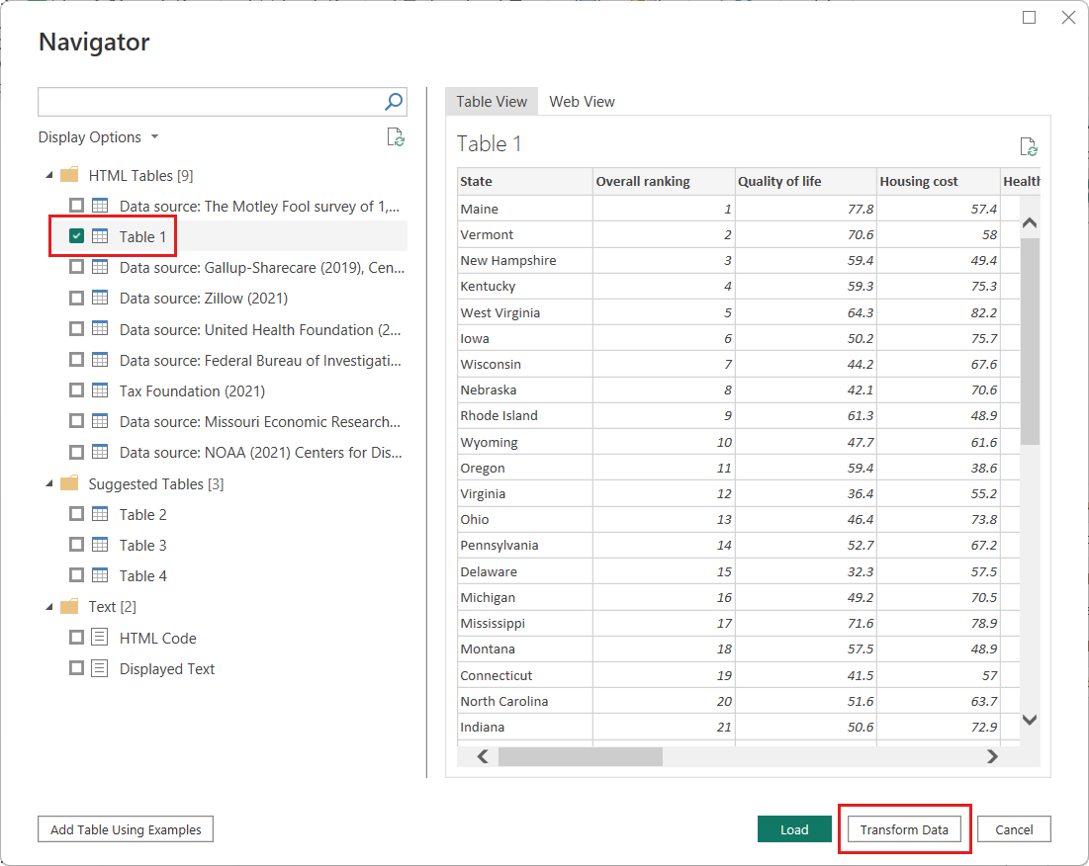

**Tip**

Some information in the tables from the previous URL may change or be updated occasionally. As a result, you may need to adjust the selections or steps in this article accordingly.

1. The Power Query Editor window opens. You can see the default steps applied so far, in the **Query Settings** pane under **APPLIED STEPS**.
   * **Source**: Connecting to the website.
   * **Extracted Table from Html**: Selecting the table.
   * **Promoted Headers**: Changing the top row of data into column headers.
   * **Changed Type**: Changing the column types, which are imported as text, to their inferred types.

[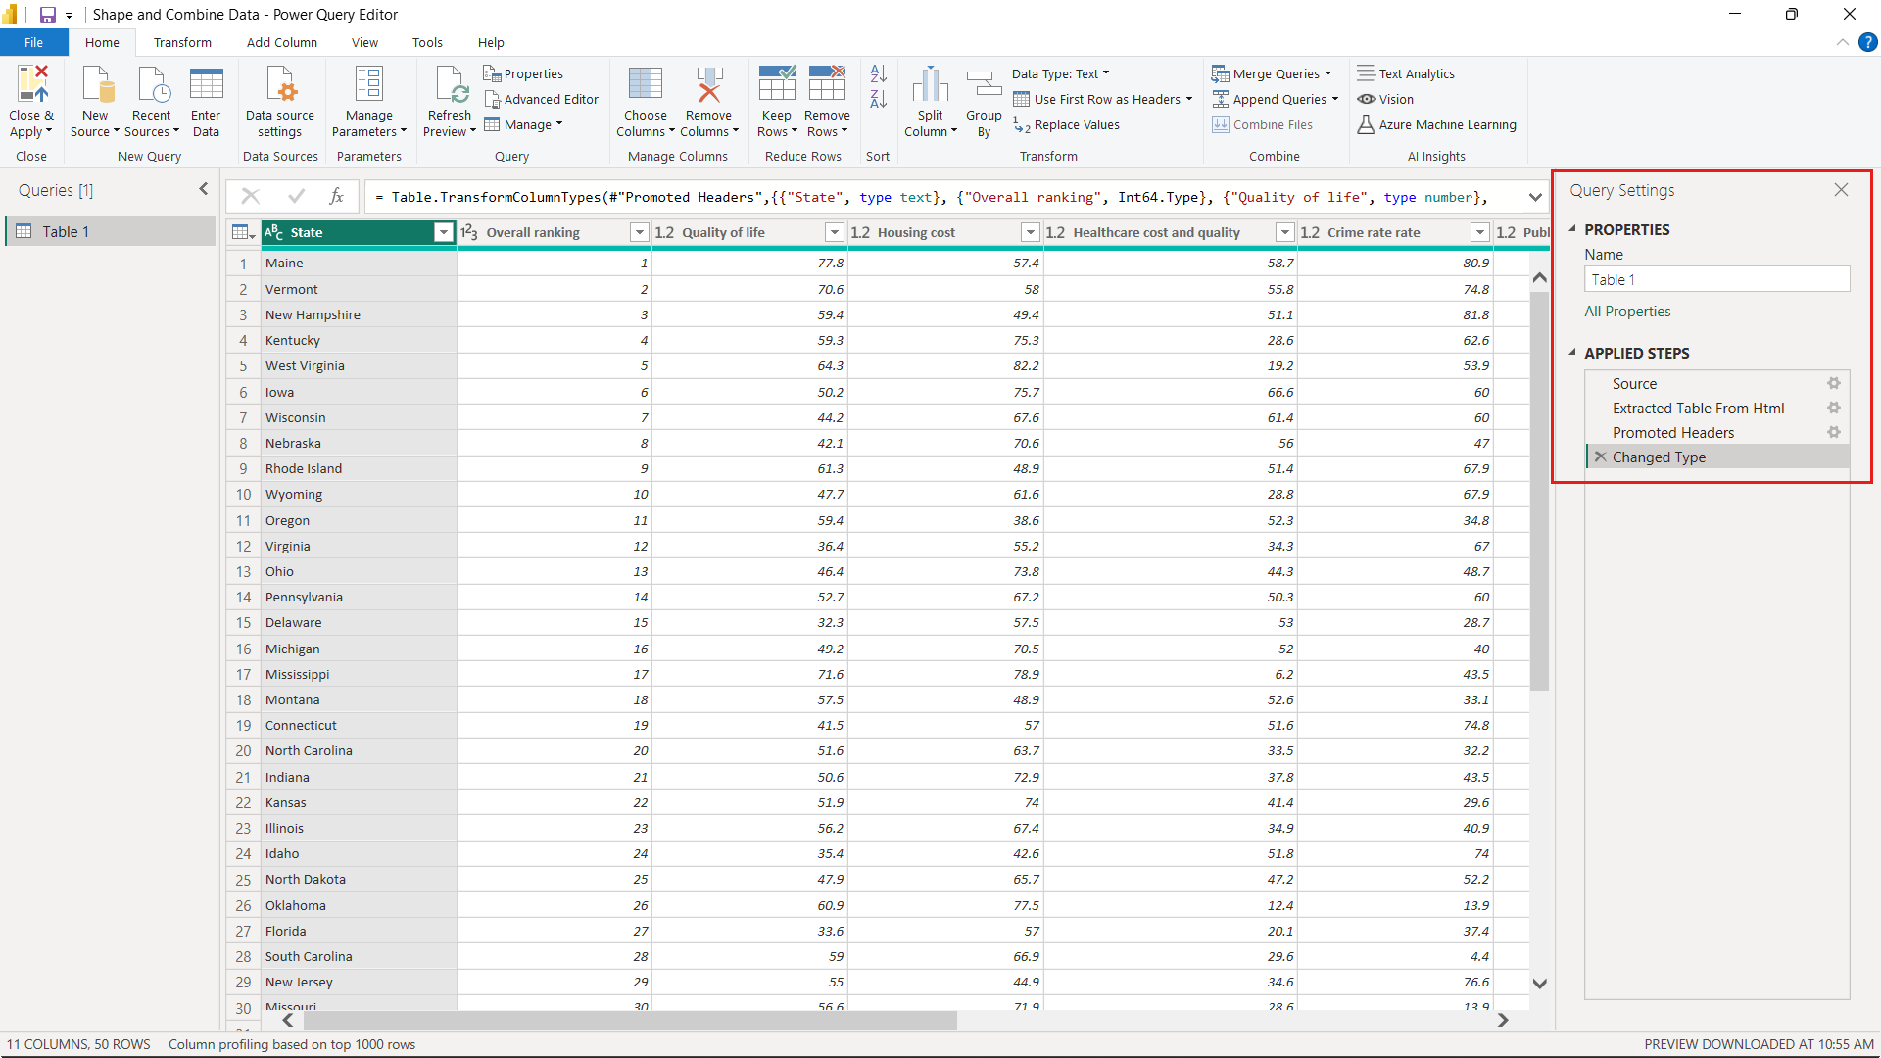](https://learn.microsoft.com/en-us/power-bi/connect-data/media/desktop-shape-and-combine-data/power-query-editor-query-settings-dialog.png#lightbox)

1. Change the table name from the default Table 1 to Retirement Data, then press **Enter**.

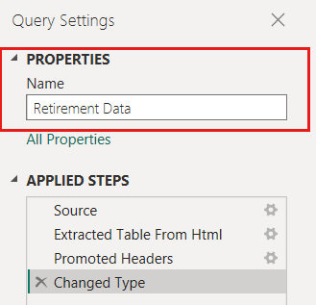

1. The existing data is ordered by a weighted score, as described on the source web page under [Methodology](https://www.fool.com/research/best-states-to-retire/#:%7E:text=Methodology). Let's add a custom column to calculate a different score. We'll then sort the table on this column to compare the custom score's ranking to the existing **Rank**.
2. From the **Add Column** ribbon, select **Custom Column**.

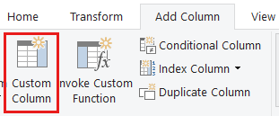

1. In the **Custom Column** dialog, in **New column name**, enter *New score*. For the **Custom column formula**, enter the following data:

Copy

( [Quality of life] + [Housing cost] + [Healthcare cost and quality] + [Crime rate rate] + [#"Public health/COVID-19 response"] + [Sales taxes] + [#"Non-housing costs"] + [Weather] ) / 8

1. Make sure the status message is *No syntax errors have been detected*, and select **OK**.

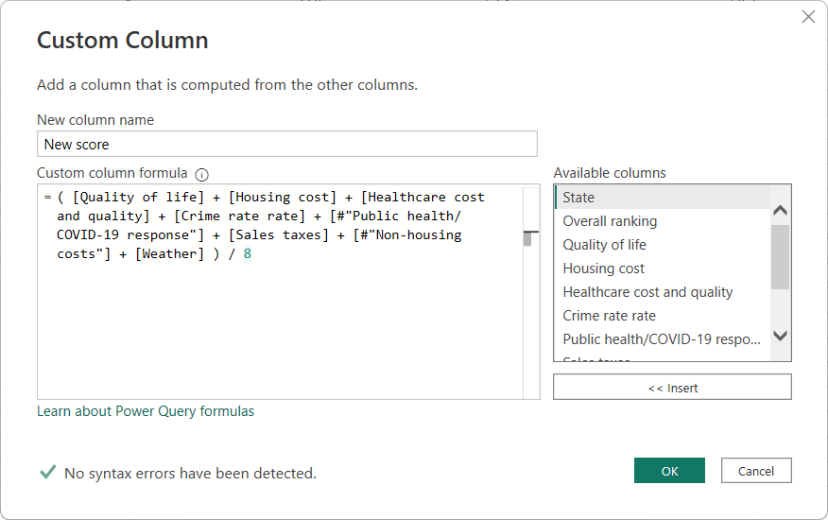

1. In **Query Settings**, the **APPLIED STEPS** list now shows the new **Added Custom** step we just defined.

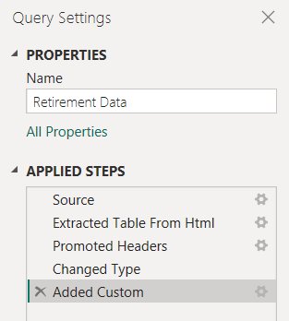

**Adjust the data**

Before we work with this query, let's make a few changes to adjust its data:

* Adjust the rankings by removing a column.

For example, assume **Weather** isn't a factor in our results. Removing this column from the query doesn't affect the other data.

* Fix any errors.

Because we removed a column, we need to adjust our calculations in the **New score** column by changing its formula.

* Sort the data.

Sort the data based on the **New score** column, and compare to the existing **Rank** column.

* Replace the data.

We'll highlight how to replace a specific value and how to insert an applied step.

These changes are described in the following steps.

1. To remove the **Weather** column, select the column, choose the **Home** tab from the ribbon, and then choose **Remove Columns**.

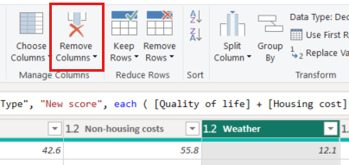

**Note**

The **New score** values haven't changed, due to the ordering of the steps. Power Query Editor records the steps sequentially, yet independently, of each other. To apply actions in a different sequence, you can move each applied step up or down.

1. Right-click a step to see its context menu.

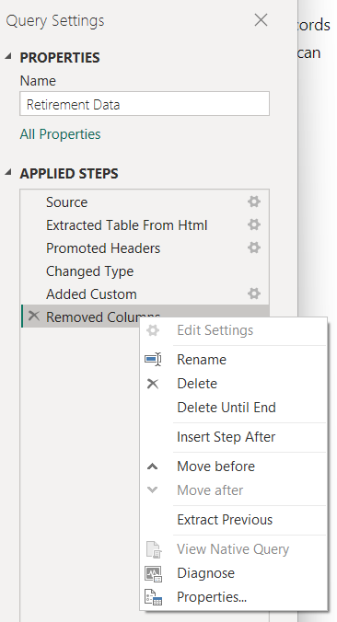

1. Move up the last step, **Removed Columns**, to just above the **Added Custom** step.

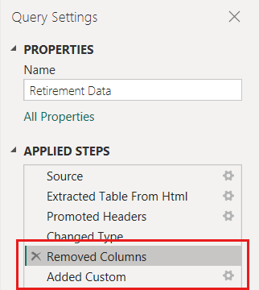

1. Select the **Added Custom** step.

Notice the **New score** column now shows *Error* rather than the calculated value.

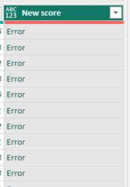

There are several ways to get more information about each error. If you select the cell without clicking on the word *Error*, Power Query Editor displays the error information.

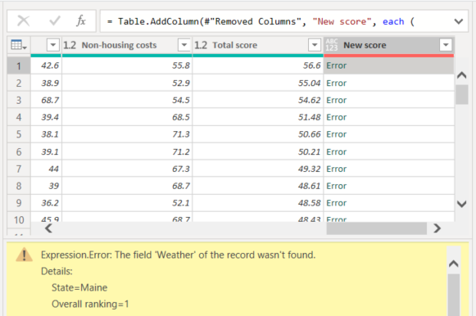

If you select the word *Error* directly, Power Query Editor creates an **Applied Step** in the **Query Settings** pane and displays information about the error. Because we don't need to display error information anywhere else, select **Cancel**.

1. To fix the errors, there are two changes needed, removing the *Weather* column name and changing the divisor from 8 to 7. You can make these changes in two ways:
   1. Right-click the **Custom Column** step and select **Edit Settings**. This brings up the **Custom Column** dialog you used to create the **New score** column. Edit the formula as described previously, until it looks like this:

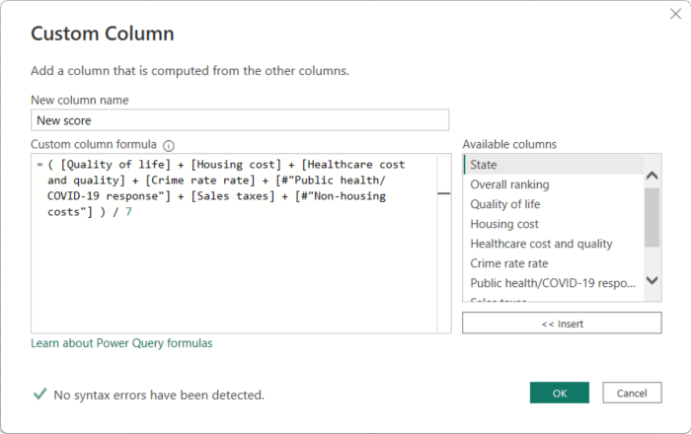

* 1. Select the **New score** column, then display the column's data formula by enabling the **Formula Bar** checkbox from the **View** tab.

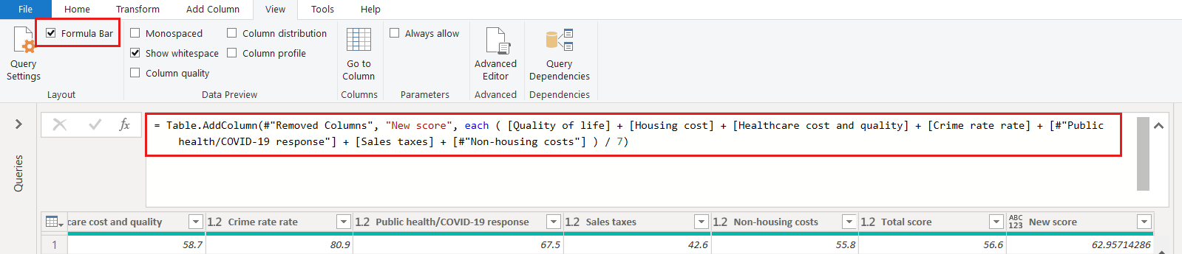

Edit the formula as described previously, until it looks like this, then press **Enter**.

Copy

= Table.AddColumn(#"Removed Columns", "New score", each ( [Quality of life] + [Housing cost] + [Healthcare cost and quality] + [Crime rate rate] + [#"Public health/COVID-19 response"] + [Sales taxes] + [#"Non-housing costs"] ) / 7)

1. Power Query Editor replaces the data with the revised values and the **Added Custom** step completes with no errors.
2. **Note**
3. You can also select **Remove Errors**, by using the ribbon or the right-click menu, which removes any rows that have errors. However, in this tutorial we want to preserve all the data in the table.
4. Sort the data based on the **New score** column. First, select the last applied step, **Added Custom** to display the most recent data. Then, select the drop-down located next to the **New score** column header and choose **Sort Descending**.

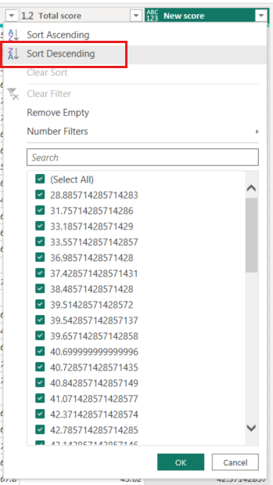

The data is now sorted according to **New score**. You can select an applied step anywhere in the list, and continue shaping the data at that point in the sequence. Power Query Editor automatically inserts a new step directly after the currently selected applied step.

1. In **APPLIED STEPS**, select the step preceding the custom column, which is the **Removed Columns** step. Here we'll replace the value of the **Housing cost** ranking in Oregon. Right-click the appropriate cell that contains Oregon's **Housing cost** value, and then select **Replace Values**. Note which **Applied Step** is currently selected.

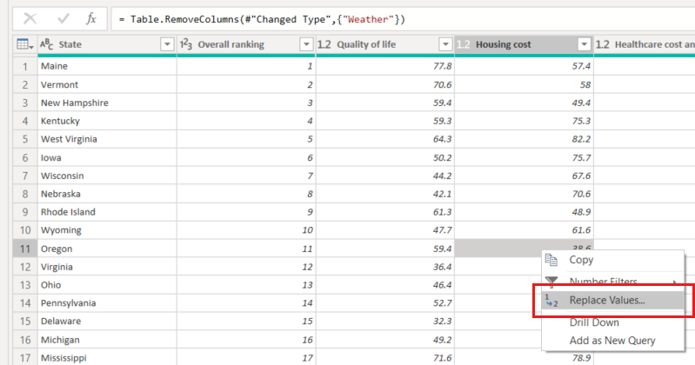

1. Select **Insert**.

Because we're inserting a step, Power Query Editor reminds us that subsequent steps could cause the query to break.

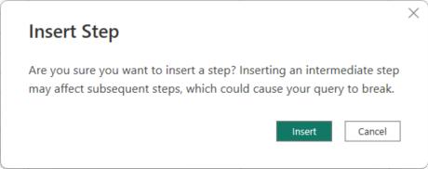

1. Change the data value to *100.0*.

Power Query Editor replaces the data for Oregon. When you create a new applied step, Power Query Editor names it based on the action, in this case, **Replaced Value**. If you have more than one step with the same name in your query, Power Query Editor appends an increasing number to each subsequent applied step's name.

1. Select the last **Applied Step**, **Sorted Rows**.

Notice the data has changed regarding Oregon's new ranking. This change occurs because we inserted the **Replaced Value** step in the correct location, before the **Added Custom** step.

We’ve now shaped our data to the extent we need to. Next let’s connect to another data source, and combine data.

**Combine data**

The data about various states is interesting, and will be useful for building further analysis efforts and queries. However, most data about states uses a two-letter abbreviation for state codes, not the full name of the state. We need a way to associate state names with their abbreviations.

There's another public data source that does provides that association, but it needs a fair amount of shaping before we can connect it to our retirement table. To shape the data, follow these steps:

1. From the **Home** ribbon in Power Query Editor, select **New Source > Web**.
2. Enter the address of the website for state abbreviations, [*https://en.wikipedia.org/wiki/List_of_U.S._state_abbreviations*](https://en.wikipedia.org/wiki/List_of_U.S._state_abbreviations), and then select **Connect**.

The Navigator displays the content of the website.

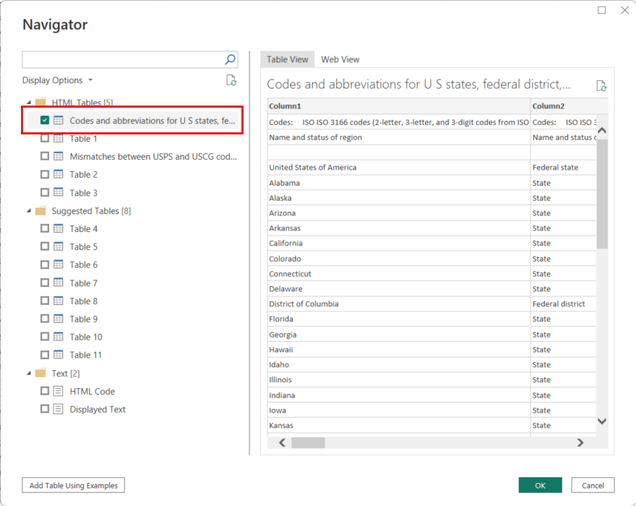

1. Select **Codes and abbreviations for U.S. states, federal district, territories, and other regions**.

**Tip**

It will take a bit of shaping to pare this table’s data down to what we want. Is there a faster or easier way to accomplish the following steps? Yes, we could create a *relationship* between the two tables, and shape the data based on that relationship. The following example steps are helpful to learn for working with tables. However, relationships can help you quickly use data from multiple tables.

To get the data into shape, follow these steps:

1. Remove the top row. Because it's a result of the way that the web page’s table was created, we don’t need it. From the **Home** ribbon, select **Remove Rows > Remove Top Rows**.

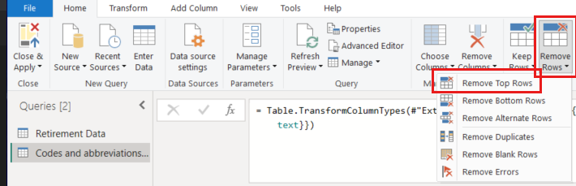

The **Remove Top Rows** dialog appears. Specify 1 row to remove.

1. Promote the new top row to headers with **Use First Row As Headers** from the **Home** tab, or from the **Transform** tab in the ribbon.
2. Because the **Retirement Data** table doesn't have information for Washington DC or territories, we need to filter them from our list. Select the **Name and status of region_1** column's drop-down, then clear all checkboxes except **State**.

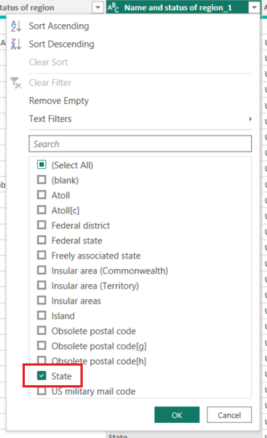

1. Remove all unneeded columns. Because we need only the mapping of each state to its official two-letter abbreviation (**Name and status of region** and **ANSI** columns), we can remove the other columns. First select the **Name and status of region** column, then hold down the **CTRL** key and select the **ANSI** column. From the **Home** tab on the ribbon, select **Remove Columns > Remove Other Columns**.

[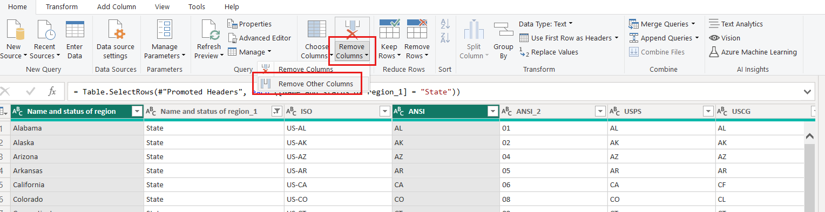](https://learn.microsoft.com/en-us/power-bi/connect-data/media/desktop-shape-and-combine-data/state-table-remove-other-columns.png#lightbox)

**Note**

The *sequence* of applied steps in Power Query Editor is important, and affects how the data is shaped. It’s also important to consider how one step might impact another subsequent step. For example, if you remove a step from the applied steps, subsequent steps might not behave as originally intended.

**Note**

When you resize the Power Query Editor window to make the width smaller, some ribbon items are condensed to make the best use of visible space. When you increase the width of the Power Query Editor window, the ribbon items expand to make the most use of the increased ribbon area.

1. Rename the columns and the table. There are a few ways to rename a column: First select the column, then either select **Rename** from the **Transform** tab on the ribbon, or right-click and select **Rename**. The following image shows both options, but you only need to choose one.

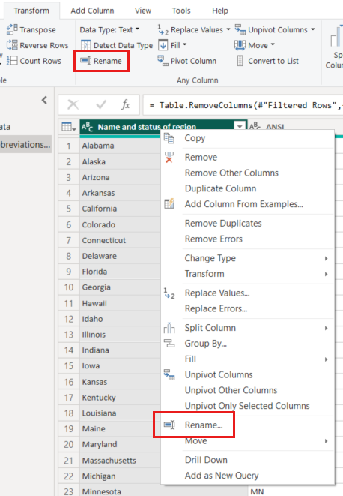

1. Rename the columns to *State Name* and *State Code*. To rename the table, enter the **Name** *State Codes* in the **Query Settings** pane.

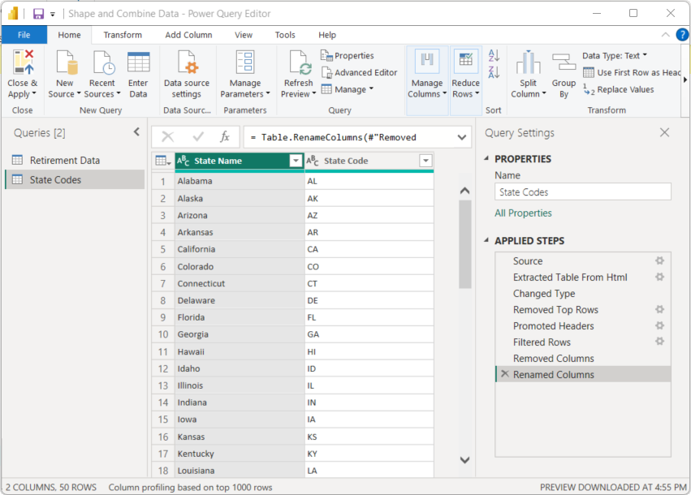

**Combine queries**

Now that we’ve shaped the *State Codes* table the way we want, let’s combine these two tables, or queries, into one. Because the tables we now have are a result of the queries we applied to the data, they’re often referred to as *queries*.

There are two primary ways of combining queries: *merging* and *appending*.

* For one or more *columns* that you’d like to add to another query, you *merge* the queries.
* For one or more *rows* of data that you’d like to add to an existing query, you *append* the query.

In this case, we want to merge the queries:

1. From the left pane of Power Query Editor, select the query *into which* you want the other query to merge. In this case, it's **Retirement Data**.
2. Select **Merge Queries > Merge Queries** from the **Home** tab on the ribbon.

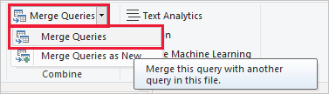

You might be prompted to set the privacy levels, to ensure the data is combined without including or transferring data you don't want transferred.

The **Merge** window appears. It prompts you to select which table you'd like merged into the selected table, and the matching columns to use for the merge.

1. Select **State** from the *Retirement Data* table, then select the **State Codes** query.

When you select a matching columns, the **OK** button is enabled.

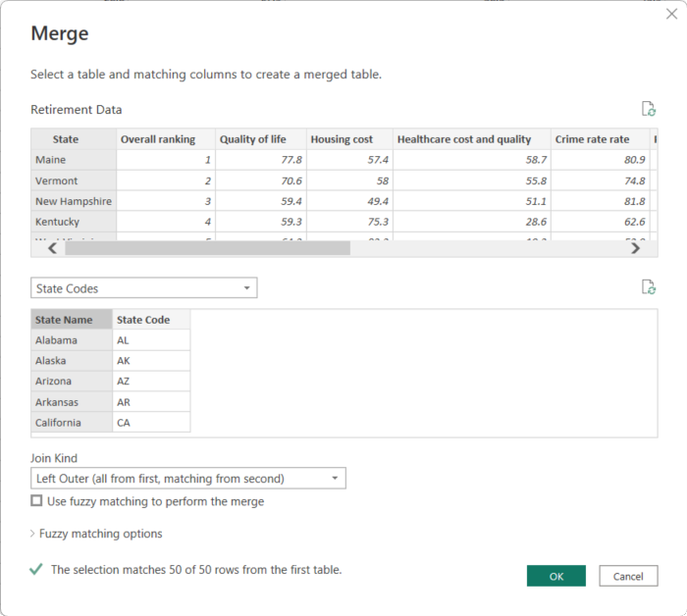

1. Select **OK**.

Power Query Editor creates a new column at the end of the query, which contains the contents of the table (query) that was merged with the existing query. All columns from the merged query are condensed into the column, but you can **Expand** the table and include whichever columns you want.

1. To expand the merged table, and select which columns to include, select the expand icon (https://learn.microsoft.com/en-us/power-bi/connect-data/media/desktop-shape-and-combine-data/icon.png ).

The **Expand** window appears.

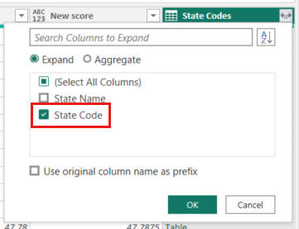

1. In this case, we want only the **State Code** column. Select that column, clear **Use original column name as prefix**, and then select **OK**.

If we had left the checkbox selected for **Use original column name as prefix**, the merged column would be named **State Codes.State Code**.

**Note**

If you want to explore how to bring in the **State Codes** table, you can experiment a bit. If you don’t like the results, just delete that step from the **APPLIED STEPS** list in the **Query Settings** pane, and your query returns to the state prior to applying that **Expand** step. You can do this as many times as you like until the expand process looks the way you want it.

We now have a single query (table) that combines two data sources, each of which was shaped to meet our needs. This query can be a basis for interesting data connections, such as housing cost statistics, quality of life, or crime rate in any state.

1. To apply your changes and close Power Query Editor, select **Close & Apply** from the **Home** ribbon tab.

The transformed semantic model appears in Power BI Desktop, ready to be used for creating reports.

